# EX1 Mnsit Project Report

#### Asaf liberman 313230187

#### Nirel Yehoyada 205386675

#### Niv Zatelman 314764812

## Part 1: MNIST – Digit Recognition

### Neural Network architecture num. 1:

1. Model architecture:
   1. Number of layers: 3
   2. Size of layers: 784, 256, 10
2. Learning rate 0.01
3. Optimization algorithm: adam
4. Loss function: softmax cross entropy with logits
5. Batch size: 300
6. Amount of epochs: 20
7. Activation functions: RELU (1st) and SOFTMAX (2nd)
8. Regularization/dropout: Not used
9. A plot of training loss and validation loss:

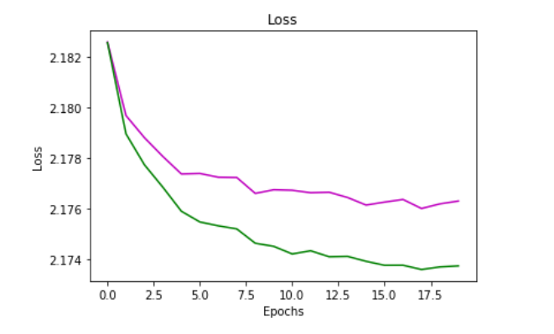

1. A plot of training accuracy and validation accuracy:

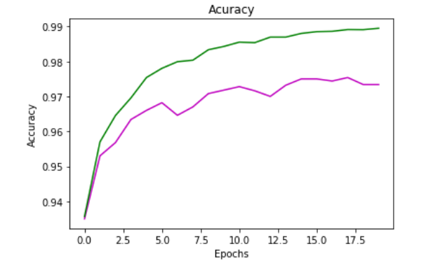

### Neural Network architecture num. 2:

1. Model architecture:
   1. Number of layers: 4
   2. Size of layers: 784, 256, 128, 10
2. Learning rate 0.01
3. Optimization algorithm: adam
4. Loss function: softmax cross entropy with logits
5. Batch size: 150
6. Amount of epochs: 20
7. Activation functions: sigmoid (1st) and softmax (2nd)
8. Regularization/dropout: Between the first hidden layer and the second hidden layer of 0.5
9. A plot of training loss and validation loss:

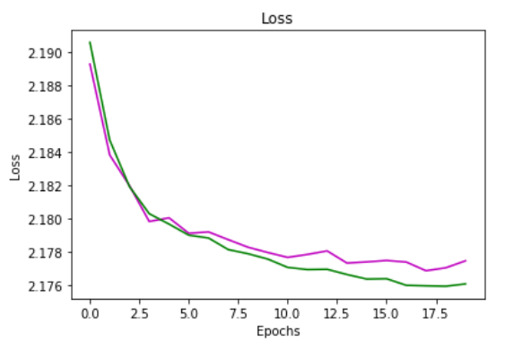

1. A plot of training accuracy and validation accuracy:

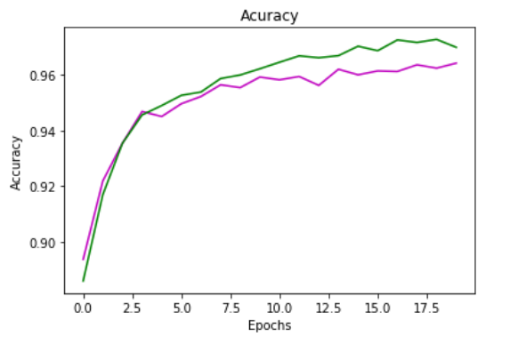

### Neural Network architecture num. 3:

1. Model architecture:
   1. Number of layers: 3
   2. Size of layers: 784, 256, 10
2. Learning rate: 0.02
3. Optimization algorithm: adam
4. Loss function: softmax cross entropy with logits
5. Batch size: 200
6. Amount of epochs: 10
7. Activation functions: Relu (1st), Softmax (2nd)
8. Regularization/dropout: Not used
9. A plot of training loss and validation loss:

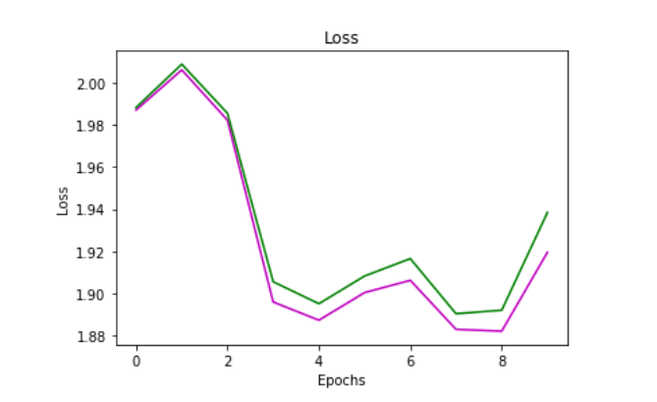

1. A plot of training accuracy and validation accuracy:

